CSCI 3022 – *Introduction to Data Science with Probability and Statistics* – **FINAL SOLUTIONS**

**Final Exam – Summer 2024 (Theoretical Portion – 75 points)**

08/08/2024

1. If you're interested in starting your own candy store and have a good credit rating, you could likely secure a bank loan for franchises like Candy Vibe, The Fudge Lodge, Corn Karmel, and Rocky Mountain Chocolate Express. Below are the startup costs (in thousands of dollars) for a selection of candy stores. These costs are assumed to follow a roughly normal distribution.

95, 173, 129, 95, 75, 94, 116, 100, 85

* 1. Find a 90% confidence interval for the population average startup costs *µ* for candy store franchises. (10 points)



nterin4

* 1. What does this confidence interval mean in the context of the problem? (5 points)

We are 90%

1. From a random sample of *n* = 40 current major league baseball players, a 90% confidence interval for the population mean *µ* of home run percentages for all current major league baseball players was determined to be 1*.*93 to 2*.*65.
   1. What does this imply that the sample mean $\overline{x}$ of home run percentages was? What is ***E (standard error)***in this case? (5 points). (Hint: If you do not know the population standard deviation the t-interval is used not z interval)

margin of error *E* is the distance from ¯*x*



to either endpoint of the interval, or equivalently, half the length of the interval. So, that implies *E* = 0*.*36.

* 1. Determine a 99% confidence interval for the population mean *µ* of home run percentages.

(HINT: First, use *E* to find the value of *s*, then use *n* and sample mean $\overline{x}$ along with the *s*.) (10 points)

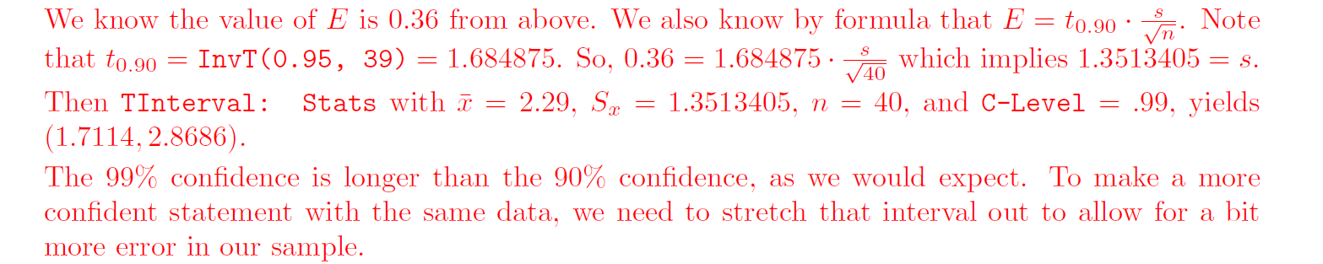

1. A *CNN* poll asked the question, “What is earth’s biggest current issue?” Nineteen percent of people asked replied, “burglaries and crime.” Assuming that the sampling error had a margin of plus or minus 3 percentage points. Following the convention that the margin of error is based on a 95% confidence interval, find a 95% confidence interval for the percentage of the entire population that would respond “Crime and violence” to the question asked by the pollsters. (5 points)



1. If the *P*-value in a statistical test is less that or equal to the level of significance for the test, do we reject or fail to reject *H*0? Does this imply that there IS or IS NOT enough evidence in the data (and the test being used) to justify the rejection of *H*0? (5 points)

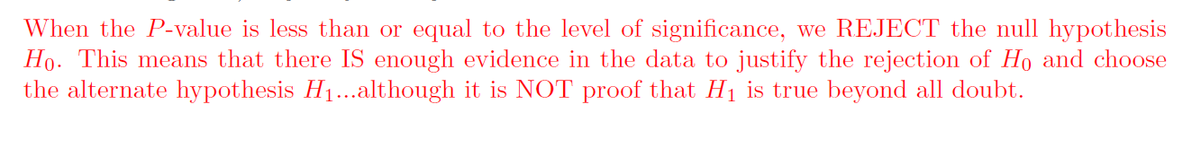

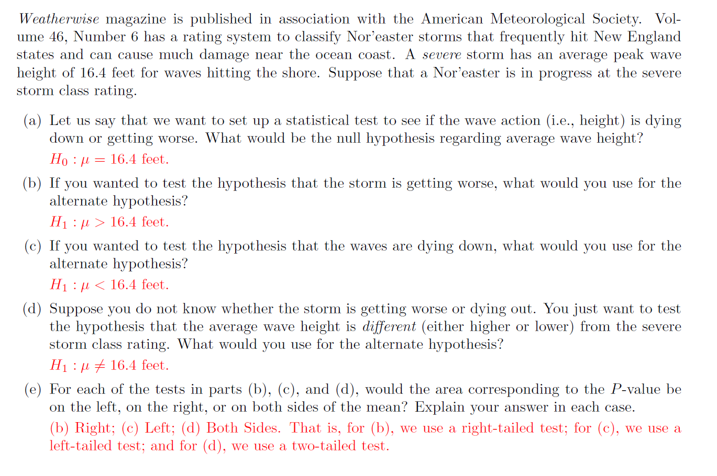

1. Gentle Ben is a Morgan horse at a Colorado dude ranch. The mean glucose level for horses should be *µ* = 85 mg/100 ml (Reference: *Merck Veterinary Manual*). Over the past 8 weeks, a veterinarian took weekly glucose readings from this horse (in mg/100 ml) and found the sample mean $\overline{x}$ = 93*.*8 mg/100 ml. Do the data indicate that Gentle Ben has an overall average glucose level higher than 85 mg/100 ml?
   1. State the appropriate null and alternate hypothesis for this test. Is this a left-tailed, right-tailed, or two-tailed test? (5 points)



0 : *µ* = 85mg/100ml *H*1 : *µ >* 85mg/100/ml This is a right-tailed test.

* 1. If we assume that *x* has a normal distribution and that we know from past experience that *σ* = 12*.*5, then the corresponding *P*-value is about 0*.*0232. Verify this is correct using the appropriate statistical test. At the *α* = 0*.*05 level, do these data indicate that Gentle Ben has an overall average glucose level higher than 85 mg/100 ml? Explain. (5 points)



1. You draw a random sample of size *n* = 64 from a population with mean *µ* = 50 and standard deviation *σ* = 16. From this, you compute the sample mean, $\overline{x}$. **Hint: Use the Central Limit Theorem**
   1. What are the expectation and standard deviation of $\overline{x}$? (5 points)

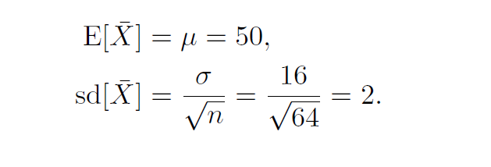

* 1. 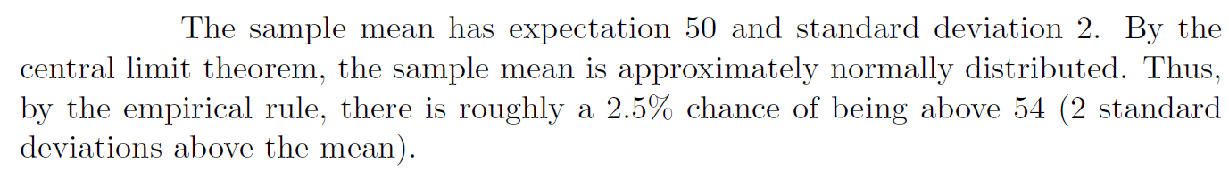Approximately what is the probability that the sample mean is above 54? (5 points)

b

* 1. Do you need any additional assumptions for this question to be true? Hint look at sample size (5 points)

